Sophie L. Kjaervik
CURRICULUM VITAE
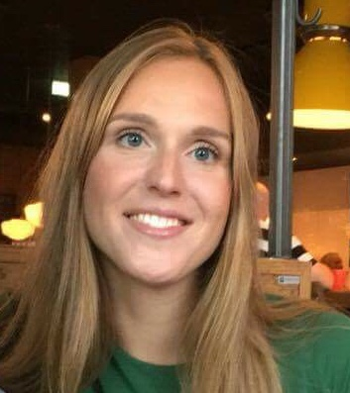
Work Address:
The Ohio State University Phone: (614) 816-7362
School of Communication Email: sophiekja@gmail.com
3016 Derby Hall, 154 N. Oval Mall Work-email: kjaervik.1@osu.edu
Columbus, OH 43210, USA
Home address:
939 Perry St., Apt. 311.
Columbus, Ohio, 43215

EDUCATION
Expected 2023 Ph.D. Major: Communication
Minor: Quantitative Methods
University: The Ohio State University
Location: Columbus, Ohio, USA

June 2019 M.A. Major: Health, Development and Community Psychology
Thesis title: “Threatened narcissists lash out aggressively:
A meta-analytic review”
Thesis co-chairs: Ole Jacob Madsen, Ph.D. (University of Oslo) and Brad J. Bushman, Ph.D. (The Ohio State University)
University: University of Oslo
Location: Oslo, Norway

August - December 2018 Position: Visiting Scholar
University: The Ohio State University
Location: Columbus, Ohio, USA

June 2017 B.A. Major: Psychology
Thesis title: “Pichação - A subculture and a form of self-
expression” (based on fieldwork conducted in Sao Paulo Brazil)
Thesis chair: Torbjørn Rundmo, Ph.D.
University: Norwegian University of Science and Technology
Location: Trondheim, Norway

June 2014 Folk High School
Major: Psychology & Charity, Explore and Travel (traveled through Peru, Bolivia, Brazil visiting and working for different charitable organizations and an orphanage in Sao Paulo, Brazil)
University: Karmøy Folkehøgskule
Location: Karmøy, Norway

WORK EXPERIENCE

2017- 2019 Care Worker
Multidisciplinary rehabilitation for patients with complex functional
impairment following illness or injury, focus on community re-entry
Sunnaas Rehabilitation Hospital
Nesodden, Norway

2017 - 2019 Care Worker
Secured home for elderly patients with dementia
Nesodden Retirement home
Nesodden, Norway

2017- 2018 Personal Assistant
Provided medical and personal care for patient with Amyotrophic Lateral Sclerosis (ALS), or Lou Gehrig's disease
Aleris Ungplan & BOI
Oslo, Norway

2014- 2017 Social Worker
Therapist for mentally ill patients with a history of substance abuse who are transitioning to independent living.
Leistad Aftertreatment Clinic
Trondheim, Norway

VOLUNTEER EXPERIENCE

2018 Social Worker Intern
Helped troubled youth
UmV, Ungdom mot Vold
Oslo, Norway

2014 - 2017 Volunteer restaurant worker
Samfundet
Trondheim, Norway

2013 - 2014 Summer Barista Volunteer
Roskilde, Denmark

SCHOLARSHIP

For my undergraduate degree and my master’s degree (including my visit to The Ohio State University), I received a stipend and student loan from the Norwegian State Educational Loan Fund. This scholarship is granted to every Norwegian student in good standing. Because every Norwegian student in good standing is fully funded, there is no reason to apply for private scholarships.

For my Ph.D. I am receiving funding from Ohio State University through the Graduate Assistantship (GA). In addition to the stipend, instructional and general tuition fees are waived.

PUBLICATIONS

Peer reviewed Journal Articles:
Kjaervik, S. L., & Bushman, B. J. (in press). The link between narcissism and aggression: A meta-analytic review. Psychological Bulletin. doi:10.1037/bul0000323

*Manuscript under review: Holt, L. F., Kjaervik, S. L., & Bushman, B. J. (2021). Harmful claims through names: examining why calling the coronavirus the “COVID-19 virus” rather than the “Chinese virus” matters.

SERVICE

Ad Hoc Reviewer:
*Aggressive Behavior
*Motivation Science
*Psychology of Popular Media
*Psychology of Violence

TEACHING

Graduate Teaching Assistant:
*Intercultural Communication (COMM 3668).
*Crisis Communication (COMM 31947).
*Social Media (COMM 3558).
*Strategic Communication Principles (COMM 2331).

Lab instructor:
*Research Methods (COMM 3160).
*Industry Research Methods (COMM 3163).

LANGUAGES SPOKEN FLUENTLY

Norwegian
English
Danish

